https://www.wpbeginner.com/guides/:
Ultimate Guide: How to Make a Website in 2019 – Step by Step Guide (Free) (wpbeginner.com)
Last updated on February 14th, 2019 by Editorial Staff
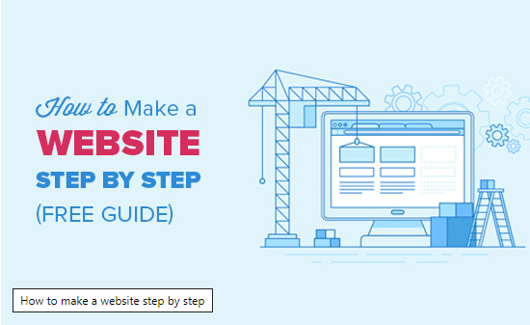
This guide is useful for users of all ages and skill levels. However, if you need help, then you can contact our expert team to help you setup your website for free.
→ Click Here to Get Your Free WordPress Website Setup! ←
If you want to do it by yourself, then please continue to follow our step by step guide on how to make a website.
Here is an overview from start to finish of all the steps we’ll walk you through in this guide.
- How to find and register a domain name for free
- Choosing the best web hosting
- How to install WordPress
- Installing a template to change your site’s design
- Creating pages in WordPress
- Customizing WordPress with addons and extensions
- Resources to learn WordPress and get support
- Taking it further, building websites with more features
Before we start creating a website, let’s cover some of the most commonly asked questions that we get.
https://www.wpbeginner.com/why-you-should-use-wordpress/:
6 Important Reasons Why You Should Use WordPress for Your Website (wpbeginner.com)
Last updated on February 14th, 2019 by Editorial Staff
Contents
1. WordPress is Free as in Freedom 4
2. WordPress is Easy to Customize with Themes and Plugins 5
3. WordPress is SEO Friendly 6
4. WordPress is Easy to Manage 7
5. WordPress is Safe and Secure 8
6. WordPress Can Handle Different Media Types 9
What Ways to Use WordPress? 10

One of the questions that we often get asked is: Why should I use WordPress? Isn’t my old site good enough? Why do I need to switch to WordPress from another platform? If you’re asking these questions, then you’re at the right place. In this article, we will share 6 important reasons why you should use WordPress. We will also cover all the different type of websites you can create with WordPress as well as showcase popular sites that are using WordPress.
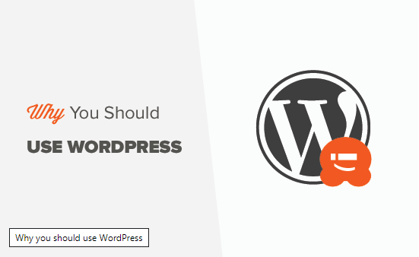
Note: Throughout this article, when we say WordPress, we are talking about WordPress.org also known as self-hosted WordPress. Please do not confuse this with WordPress.com which is a hosting service. For details, see our comparison of WordPress.org vs WordPress.com.
One of the most common misconception about WordPress is that it is just a blogging platform.
It is not.
While WordPress started as a blogging tool, it has evolved throughout the years into a powerful website builder and a robust content management system (CMS).
The best part about WordPress is that it’s easy to use and flexible enough to make different types of websites. That’s the main reason why WordPress has grown so much in popularity. According to a recent survey, WordPress powers 32.3% of all websites on the internet.
Due to it’s robust features, many of the top brands use WordPress to power their websites including Time Magazine, Facebook, The New Yorker, Sony, Disney, Target, The New York Times, and more.
Let’s take a look at why you should use WordPress to make your website.

WordPress is Free as in Freedom
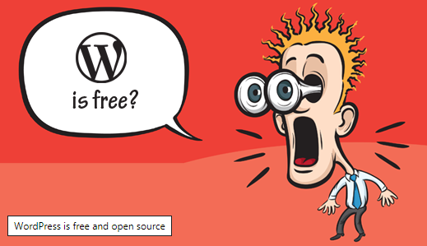
WordPress is a free software. It means you are free to download, install, use and modify it to match your needs. You can use it to create any kind of website. To learn more, see our article about why is WordPress free?.
While the WordPress software itself is free, you need a domain name and web hosting to install it.
A domain name is the address of your website on the internet. This is what your users type in their browser’s address bar to access your website (for example, wpbeginner.com).
Web hosting is your website’s house where all your website files are stored.
We recommend using Bluehost. They are one of the largest hosting companies in the world and an officially recommended WordPress hosting provider.
They are also offering WPBeginner users a 60% discount on hosting and a free domain name. Basically, you can get started for $2.75 per month.

Need more hosting recommendations? See our pick of the best WordPress hosting providers.
If you want someone experienced to setup your WordPress site, then our talented staff members are happy to help you get started. The best part is that we offer a free WordPress blog setup service.
You can also do it yourself by following our step by step guide on how to install WordPress.
If you run into any issues with WordPress, simply type your question in Google and add wpbeginner at the end of your question. You will likely find the answer on our website.

WordPress is Easy to Customize with Themes and Plugins
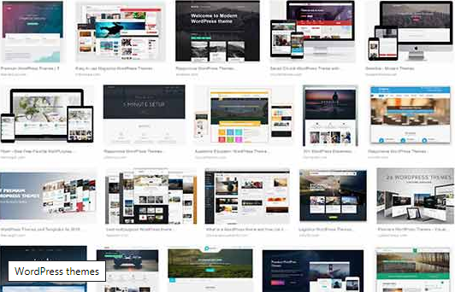
A large portion of people using WordPress are neither web designers nor programmers. As a matter of fact, most folks start using WordPress without any prior knowledge of designing websites.
For non-tech savvy folks, WordPress is the perfect solution because there are thousands of free website templates (themes) that you can choose from. There is a perfect WordPress theme for just about every kind of website (whether it’s a blog, business site, or an online store).
WordPress themes are easy to customize because a lot of them come with their own options panel allowing you to change colors, upload logo, change the background, create beautiful sliders, and truly customize it to your needs without writing any code at all.
You can also add custom functionality to your WordPress site by using plugins. WordPress plugins are like apps for your website that you can use to add advanced features like analytics, contact forms, membership area, and more.
Just like themes, there are thousands of free and premium plugins available for you to use. To learn more, see our article on what are WordPress plugins and how do they work.
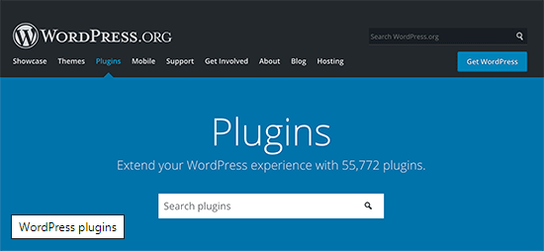
Aside from adding extra functionality, some WordPress plugins can let you transform your website into a completely new platform. Take a look at our expert pick of essential WordPress plugins for every website.

WordPress is SEO Friendly
WordPress is written using standard compliance high-quality code and produces semantic markup. In non-geek terms, this makes Google and other search engines love WordPress.
This is why WordPress sites tend to rank higher than others in search engines.
By design, WordPress is very SEO friendly out of the box. You can also use WordPress SEO plugins to further optimize your website. For complete step by step instructions, see our ultimate WordPress SEO guide to properly optimize your website.

WordPress is Easy to Manage
WordPress comes with a built-in updates management system. This allows you to update your plugins and themes from within your WordPress admin dashboard.
WordPress also notifies you when there is a new version of WordPress available, so you can update your site by simply clicking a button.
To protect your data from any accident or hacking, you can easily use a WordPress backup plugin to automatically create backups and store them safely on a remote location.
You can also manage your WordPress site on the go with WordPress mobile apps.

WordPress is Safe and Secure
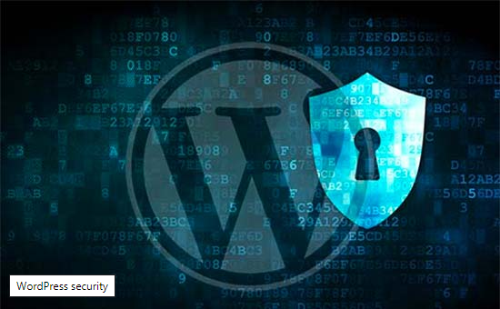
WordPress is developed with security in mind, and it is considered to be a very safe and secure platform to run a website. However, just like the real world, the internet can be an uncertain place.
There are intruders out there who want to get their hands on as many sites as they could. To protect your WordPress site, there are a few simple things that you can do to make it even more secure. For details, see our step-by-step WordPress security guide for beginners.
We use Sucuri on our websites to protect against common threats such as brute force attacks and malware.

WordPress Can Handle Different Media Types
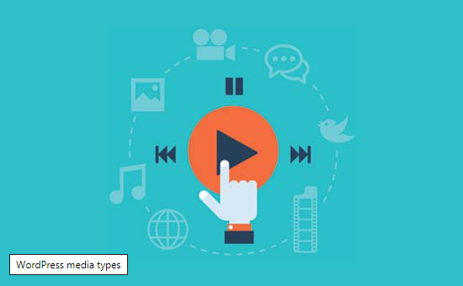
WordPress is not just limited to writing text. It comes with a built-in media uploader to handle images, audio, and video files.
WordPress supports oEmbed enabled websites which means you can embed YouTube videos, Instagram photos, Tweets, and Soundcloud audio by just pasting the URL in the WordPress post editor.

What Ways to Use WordPress?
WordPress can be used in many different ways from simple websites to eCommerce marketplaces and anything in between.
Following are just a few examples of different kind of websites you can make with WordPress.
- Start a Blog
- Make a business website
- Start an online store
- Build a membership website
- Sell online courses
See our full list of 19 different types of websites you can make using WordPress.
We hope this article answered your question about why you should use WordPress. The best way to truly experience the power of WordPress is by using it. Give it a try, and let us know what you think.
If you liked this article, then please subscribe to our YouTube Channel for WordPress video tutorials. You can also find us on Twitter and Facebook.
